In Java, the final keyword can be used while declaring an entity. Using the final keyword means that the value can’t be modified in the future.

Final variables
If a variable is declared with the final keyword, its value cannot be changed once initialized. Note that the variable does not necessarily have to be initialized at the time of declaration.

Definition and Usage
The final keyword is a non-access modifier used for classes, attributes and methods, which makes them non-changeable (impossible to inherit or override).
The final keyword is useful when you want a variable to always store the same value, like PI (3.14159...).
The final keyword is called a "modifier"

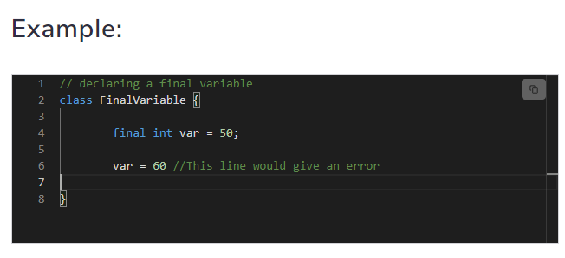
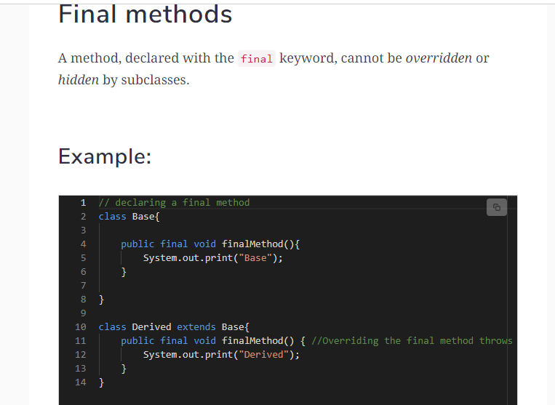
Output

main.java:11: error: finalMethod() in Derived cannot override finalMethod() in Base public final void finalMethod() { //Overriding the final method throws an error ^ overridden method is final 1 error
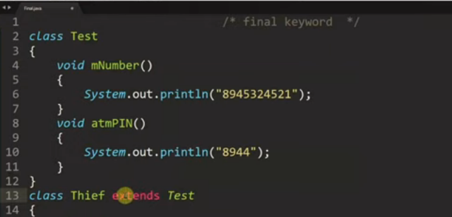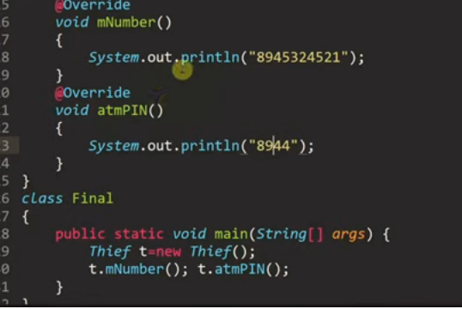

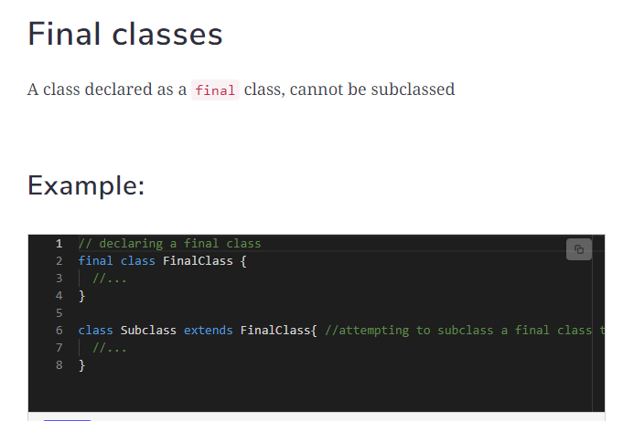

Output

main.java:6: error: cannot inherit from final FinalClass class Subclass extends FinalClass{ //attempting to subclass a final class throws an error ^ 1 error

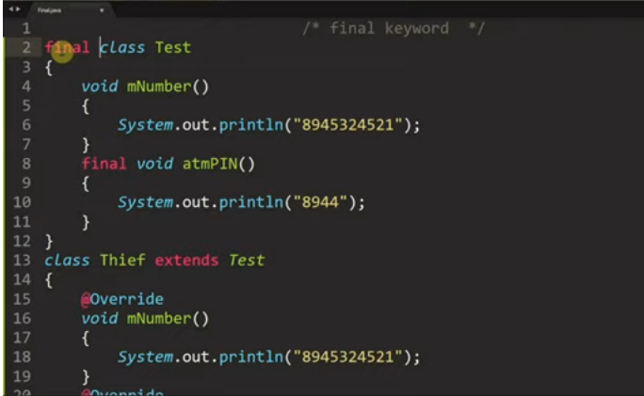
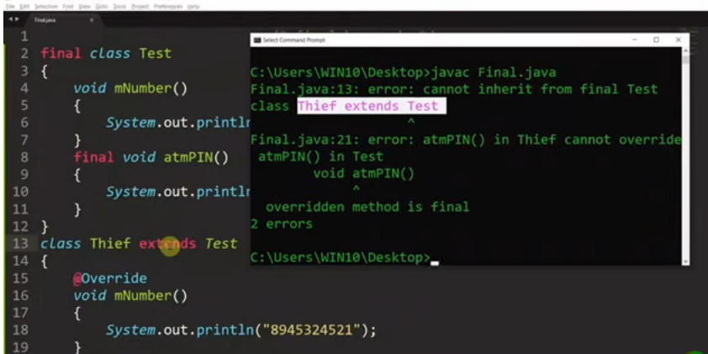

1.Default constructor

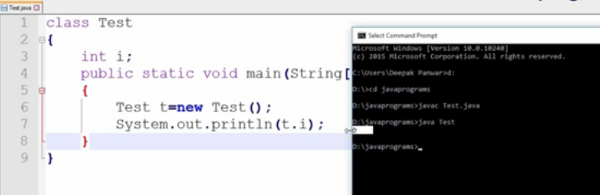

2. No arg constructor
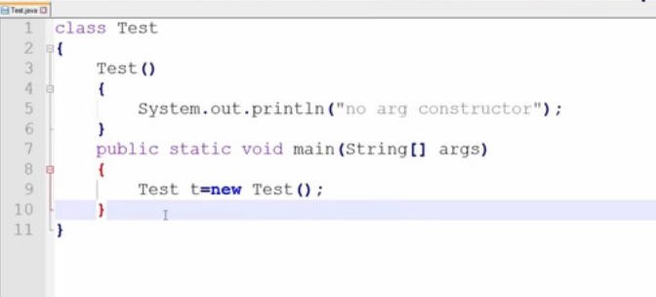

3. parameterized constructor

